**Installing Xampp ,Subline and FileZilla on PC**

Download Xampp from the website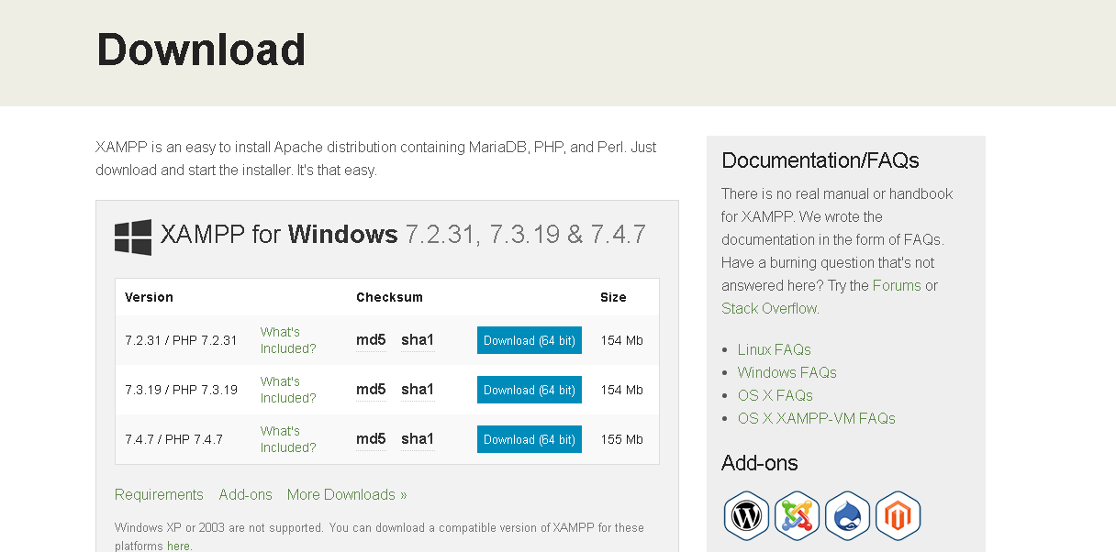

Then follow the setup instructions(just go with next) 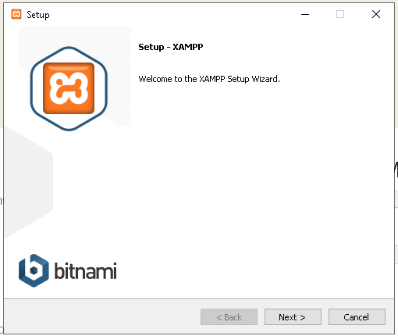

Click next until it starts the installations

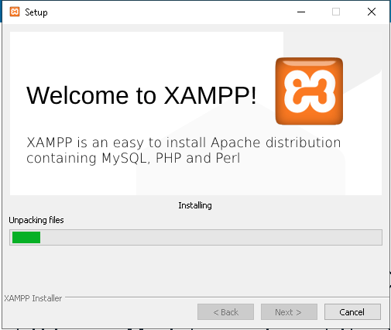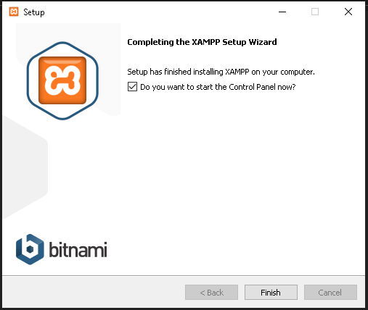

Finally, This is the interface of XAMPP Control Panel

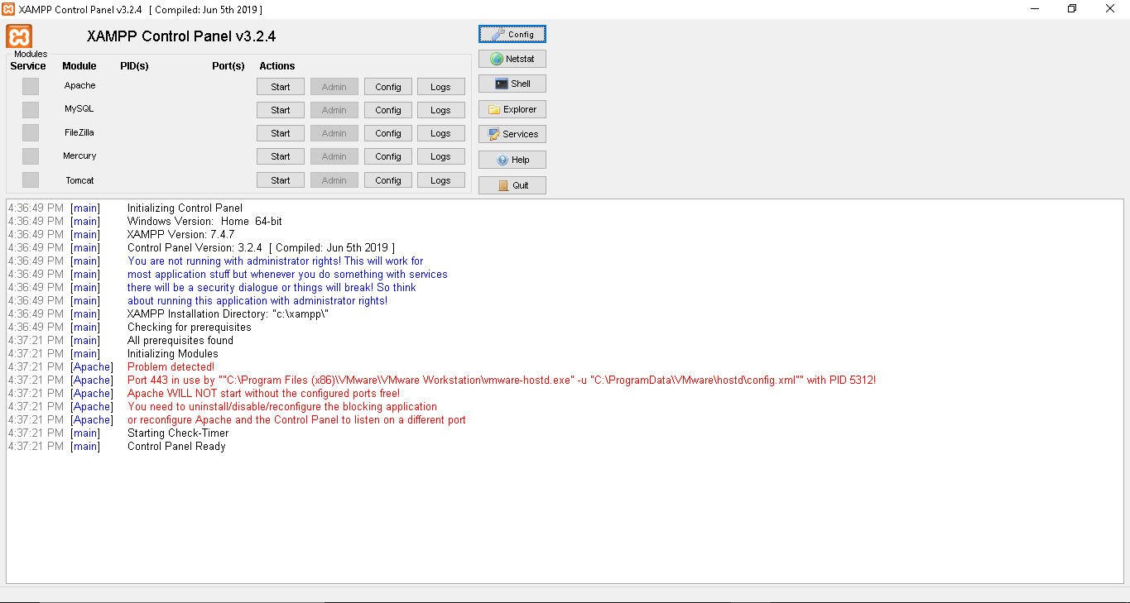

Download FileZilla from the website

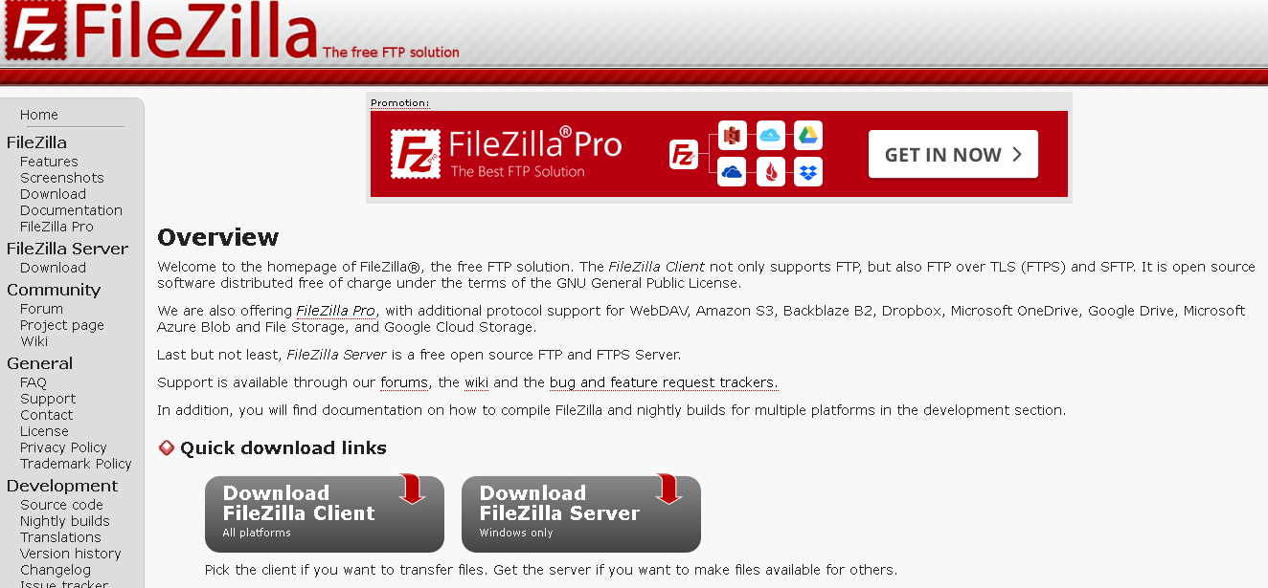

And click next

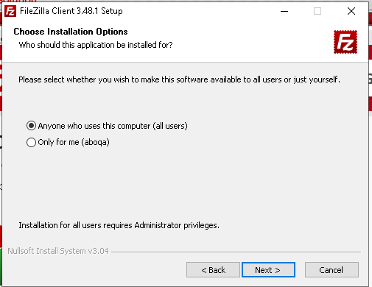

And its Finished

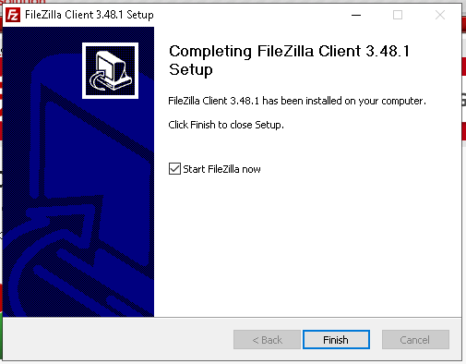

FileZilla Interface

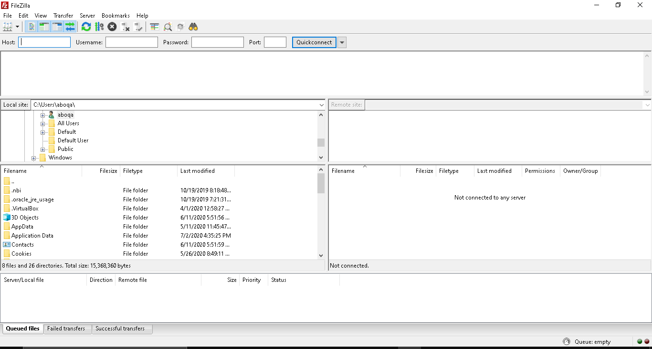

Download Sublime from the website it will directly complete your installation quiet easy.

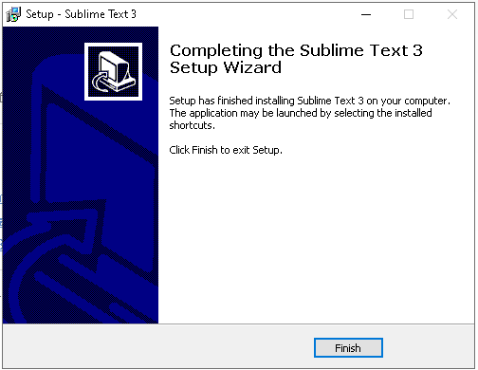

Sublime Interface

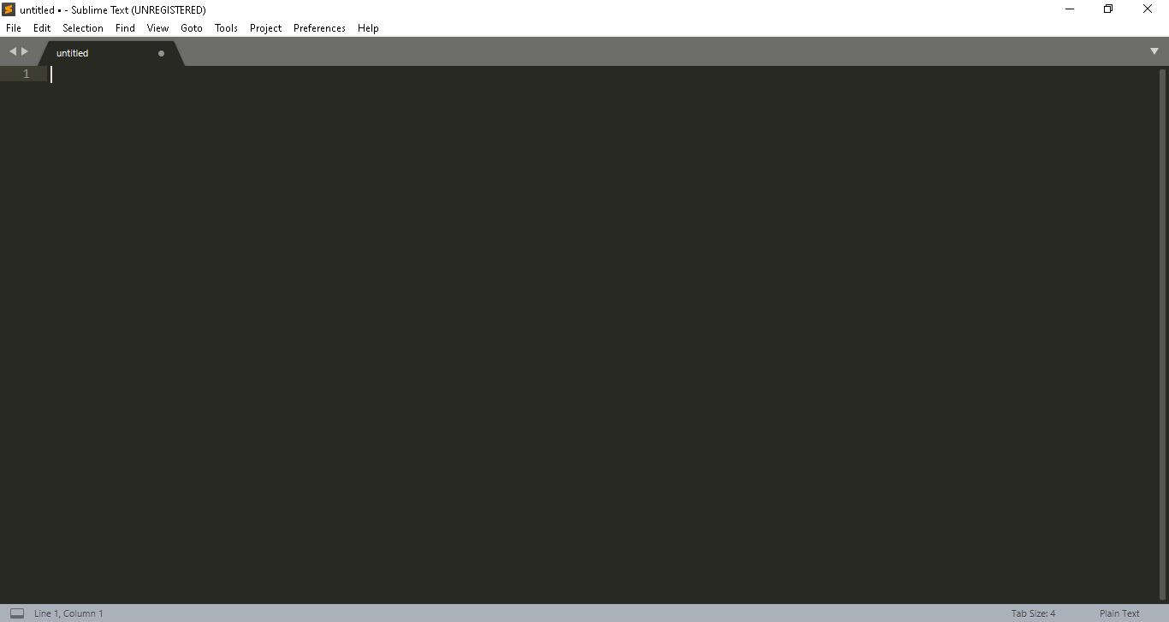

And this how you install Xampp ,Subline and FileZilla on your PC